**Practice Sheet**

**Chapter 4 (EER Models)**

*Solutions are at the end of the document. SOLVE IT YOURSELF first.

Question 1: An organization depends on a number of different types of persons for its successful operation. The organization is interested in the following attributes for all of these persons: SSN, Name, Address, and Telephone. A person may have multiple telephone numbers. Three types of persons are of greatest interest: employees, volunteers, and donors. Employees only have a Date Hired attribute, and volunteers only have a Skill attribute. Donors only have a relationship (named Donates) with an Item that has a unique number and name. A donor must have donated one or more items, and an item may have no donors, or one or many donors.

There are persons other than employees, volunteers, and donors who are of interest to the organization, so that a person need not belong to any of these three groups. On the other hand, at a given time a person may belong to two or more of these groups (for example, employees and donors).

Draw an **EER diagram** based on the requirements above. Write down assumptions (if any) you make in your answer.

Question 2: You are going to design a management system for an art gallery that organizes various art exhibitions.The requirements are given below.

1. Each exhibition event in the gallery has an id, theme, title, date, time, registration fees for artists and price for tickets.
2. Each exhibition will host several items. The items will have an id, title, description, selling price if it is for sale and location within the gallery where it is placed for exhibition. A single item may be showcased in several exhibitions. The items are of two types: paintings and sculptures. For paintings, there should be a type attribute to store if it is oil painting, acrylic etc.
3. All exhibition items/art are created by artists. All necessary personal and contact information of the artists are also stored.
4. Visitors will register online to purchase a ticket to the event. Necessary personal/contact information of visitors will be saved in the database.
5. The visitors can also buy items from the exhibition.

Draw an **EER** diagram. Write all assumptions(if any).

Question 3: A library service wants to create a database to store details of all its different libraries, books and borrowers. Details include the following:

* The service has several Libraries. Every library has a unique name, phone and a location.
* The library is either a main library or a branch library. A main library may have zero or more branch libraries and every branch library is a branch of exactly one main library.
* Books are stored in one of the libraries. A book has a unique ISBN number, a title, year and one or more authors. Since each library may have several copies of the same book, the copy number and price of each book copy is also stored for each library.
* A borrower has a name, phone and a unique ID.
* A borrower can borrow many books from any library. The copy_number, borrow_date, returned_date and due date is recorded. A borrower could borrow the same book on several occasions, but it is assumed that each such loan will take place on a different date.

Question 4: Inside Inc. is a small career development services company for young professionals. They provide career consultations to applicants looking for entry-level jobs. The data requirements is as follows:

* They offer three types of services: resume, interview practice and mentorship. Services have a unique id, start date, start time, duration, price.
* Customers purchase any number of services.
* The company has many types of Employees. Employees have unique employee id, name, email, and phone.
* Two types of special employees are Career Advisor and Client Manager.
* A career advisor talks with a customer to determine their name, unique NID, phone, email, their strengths, skills and weaknesses.
* The client manager assigns an industry consultant to the customer. The industry consultants have a unique NID, phone number, expertise and email address.

Draw an **EER diagram** based on the requirements above. Write down assumptions (if any) you make in your answer.

Question 5: Design an EER diagram for a Hospital Management System. The hospital wants to keep track of all their doctors, nurses, other staff, wards, patients and appointments. They have hired you to help them design the database for that purpose.

You can design your EER as you wish, but it must satisfy the following constraints:

1. there should be at least one disjoint-total specialization/generalization.
2. There should be at least five regular/strong entities [excluding subclasses]
3. There must be a weak entity
4. There must be at least one M:N relationship.
5. There must be at least one derived attribute.

Show all important attributes, entities and relationships in order to represent a clear and complete scenario. The EER diagram should be logically accurate and realistic, representing the database of the given scenario.

Question 6: Design an EER diagram for an Hotel Management System. The hotel wants to keep track of all their employees, customers, bookings, rooms and services. They have hired you to help them design the database for that purpose.

You can design your EER as you wish, but it must satisfy the following constraints:

1. there should be at least one overlapping-partial specialization/generalization.
2. There should be at least five regular/strong entities [excluding subclasses]
3. There must be a recursive relationship.
4. There must be at least one 1:1 relationship.
5. There must be at least one multivalued-composite attribute.

Show all important attributes, entities and relationships in order to represent a clear and complete scenario. The EER diagram should be logically accurate and realistic, representing the database of the given scenario.

**—--------------------------------Go through solution only after you tried yourself—---------------------------**

Answer 1:



Answer 2:

[Note: created_by can also be n:m, also artist can have total participation depending on assumption.The attributes of visitors and artists should be assumed, for example: name, id, phone and email.

**Hmm uhm uh**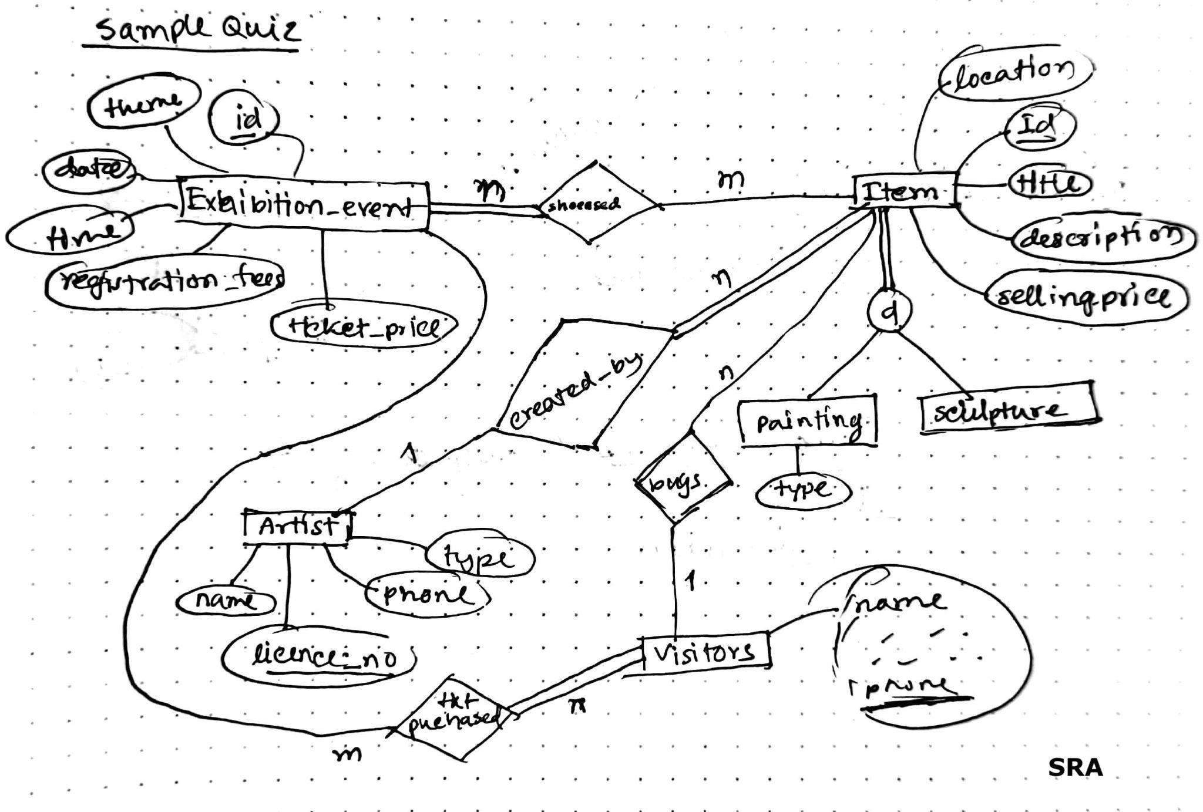

Answer 3:



Answer 4:



Answer 5 and 6:

Question 5 and 6 have no specific solutions and it is highly likely that everyone will have a different diagram. You only have to ensure that the conditions are fulfilled and that the diagram is logical for the given scenario. Make sure all entities have attributes and that strong entities have at least one key attribute.